Genesee Sno-Packers Snowmobile Club Inc.
Membership Application for 2018 – 2019 year
Mail to: PO Box 62 Oakfield, NY 14125

Mail to: PO Box 62 Oakfield, NY 14125
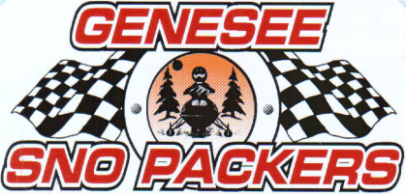
Page 1

Type of Membership: Previous year NYSSA Voucher #: ____________
[ ] Single (one person) $35.00
Please advise if you are a member of another NYSSA Club [ ] yes [ ] no
[ ] Family membership $35.00 If so, Deduct $5 and enter club name here:

[ ] NYSSA Trail Defender membership $20 ____________________________________________________________

[ ] Additional Donation $___________ [ ] Genesee SnoPacker Long Sleeve Shirt $20 (Enter Size ______)

[ ] NYSSA “Super Raffle” Ticket $5 Total Amount Paid $_____________________
Check #___________ Or CASH (select option)

**IMPORTANT**Make sure NAME and ADDRESS match your snowmobile registration!

First Name: ________________________________ Last Name: ________________________________________

Spouse: ___________________________________ Phone: ______________________ Can we Text You? Yes or No

Children under 18:_____________________________________________________________________________________

Address: __________________________________ PO Box: __________________________________________

Town/City: ________________________________ Zip: ______________________________________________

Email Address: _______________________________________________________________________________________

***Please make sure not to write on your voucher other than signature for the DMV.

Check Events in working:

 Chicken Barbeque  Special Needs/Challenger Event  Winter Fest  Bikini Ralley  Trail Work

Liability Disclaimer:
I will be responsible for myself and any passengers and assume all risks and liabilities in the event of an accident, fire, and theft to myself, my equipment or vehicle. I will not hold the Genesee Sno-Packers Inc. or landowners responsible in event of injury or damage. I will follow and obey all New York State laws involving snowmobiles. I have read the NYS General Obligation law 9-103 and understand that snowmobiling is a dangerous activity, which can result in injury or death.
Trail conditions vary constantly because of weather changes and snowmobile use. I also understand that ice, variations in terrain, moguls, rocks, forest growth, debris and other obstacles and hazards, including other snowmobilers, exist throughout the area. I will not make a claim against Genesee Sno-Packers Inc., landowners, officers or members. I submit this application and promise to comply with all current and future rules and regulations of the Genesee Sno-Packers Inc. Snowmobile Club.

Signature: ____________________________________________________________________________

